**Converting a Production Major Havoc PCB to Support Major Havoc – The Promised End or Major Havoc – Tournament Edition**

Draft 1.11 – 7/25/2022

Jess M. Askey – [jess@askey.org](mailto:jess@askey.org)

**Important Speech Note:** In Spring 2021, I was having issues getting speech sounding decent via the TMS5220 and COVID was giving me WAAAY to much time to think about this. After some research, I found that it would be possible to replace the TMS-5200 (which uses LPC encoding) with an MSM-6295 (which uses ADPCM encoding, and is common on later Atari games such as S.T.U.N.N. Runner). The ADPCM IC does require another EPROM as part of the daughtercard but it allows much higher quality speech. The ROM’s for ThePromisedEnd are available for EITHER choice, you just need to add missing components to the PCB and burn the correct set of EPROMS. You can also do even less mods and have NO SPEECH if you prefer. The ADPCM speech daughtercard allows you to easily change the speech phrases using a utility program and an EPROM burner.

Depending on which choice you make, you will need to do the following mods to your PCB. It is not possible to configure a PCB to easily support EITHER speech option without moving around some jumpers.

1. NO SPEECH
   1. ALPHA Mod
2. TI TMS-5220 Speech (Lower Quality)
   1. ALPHA CPU Mod
   2. GAMMA CPU Mod
   3. -5V Supply Mod
   4. LPC
3. OKI MSM-6295 Speech (Higher Quality)
   1. ALPHA Mod
   2. -5V Supply Mod
   3. ADPCM Speech Components Mod
   4. SPEECH Daughtercard – info here

**Summary**

In order to support the updated ROM’s, several modifications need to be performed on the production Major Havoc PCB. The modifications are moderately challenging (no cutting however) and you should understand that you might harm your PCB if you make mistakes, do not perform these modifications if you are not willing to accept the risks. If done cleanly, the mods are easily reversible because no cutting is required to support Major Havoc – The Promised End.

Overall, only ONE major thing needs to be accomplished in order to run the updated ROM images.

1. Expand the Paged Alpha ROM space

The overall process involves adding a single IC to a ‘Spare’ location on the production PCB.

The modified PCB **\*will\*** still support running production ROM’s if you care to revert back and if you modify to instructions, you can run original ROM’s on a modified PCB by simply pulling the new IC @ 5S and putting in the original ROMs.

ROM Notes: In the ROM section of this site, refer to the ROM Information.txt file on details about the ROM files and what devices are required for each image. You will need different EPROM’s than the stock Major Havoc ones… notably, there are (2) 27256[32K], (5) 27128[16K], (1) 272001[256K] and (1) 2764[8K] EPROM’s required.

Note on Machine Pin Sockets vs Flat Pin Sockets: I actually find the flat sockets to work better even tho they are cheaper. The pins bend out to solder on very nicely. Also, on machine pin sockets, the bottom of the socket pin may inadvertently short to the pin in the socket below, if that happens, it may damage the circuitry. Be aware of those contact considerations. I now suggest you use a flat socket for the speech IC @ 11N if it is not already installed.

**Parts List**

The following parts are required for each upgrade Section – Note: Different PCB’s may have some parts stuffed from the factory.

Alpha CPU Mod:

1. (1) 16-Pin DIP Socket (machine pin or flat)
2. (2) 28-Pin DIP Socket (flat pin suggested, see notes)
3. (1) 74LS174 Hex Flip-Flop
4. (1) 10K 1/8 W resistor

Gamma CPU Mod:

1. (1) 28-Pin DIP Socket (flat pin suggested, see notes)

-5V Supply Mod:

1. 7905 -5V Regulator
2. 1uf 25V Axial Capacitor
3. 1N4001 Diode

Speech Components (Optional):

1. (1) 10K 1/8w resistor
2. (1) 4.7K 1/8W resistor
3. (1) jumper wire
4. (1) .22uf 50v Mylar Capacitor
5. (1) 28-pin DIP Socket (note: some PCB’s have the Speech IC socket already stuffed @ 11N)
6. (1) HavocADPCM daughterboard, info on how to build or buy on the main page.

**Alpha Upgrade Procedure:**

1. Remove the ROM’s at locations 1Q and 1N/P (Paged ROM)
2. Solder in a 16-pin DIP socket @ location 5S.
3. Take 2 28-pin DIP sockets and bend pin 27 outwards horizontally so it will stick out when the socket is inserted, you will be soldering wires to these.
4. Plug your modified socket into the main sockets @ 1Q and 1N/P
5. On the component side, solder a wirewrap wire (30ga Kynar suggested) between pins 27 on 1Q and 1N/P. This line is the chip select for the added Paged ROM space. When you solder to the pin, I suggest that you wrap the wire around the pin so it doesn’t just pop off when you solder to it. You will be soldering another wire to the pin @ 1N/P for reference.
6. Now, moving to the solder side (underside of the PCB) we will start adding the new wires for the page select.
7. Solder a wire from the new socket @ 5S, pin 1 (Reset) to the Alpha CPU 6502 @ 2S pin 40.
8. Solder a wire from the new socket @ 5S, pin 9 (Clock) to the Address Decoder 74LS138 @ 5N pin 10.
9. Solder a wire from the new socket @ 5S, pin 13 (D2) to the Data Buffer 27LS244 @ 5R pin 16.
10. Solder a LONG wire from the new socket @ 5S, pin 12. You are going to then take this wire up to a through hole in the PCB (see picture below) and then route this wire under capacitor leads to help guide the wire towards the ROM socket @ 1N/P… solder this wire neatly to pin 27 @ 1N/P.
11. Solder your 10K 1/8W resistor from 5S pin 12 (step above)… to 5S pin 16 (+5v).. this is simply a pullup resistor.

**Speech Upgrade steps:**

1. If you do not have a socket installed @ location 11N, install one now Photos:

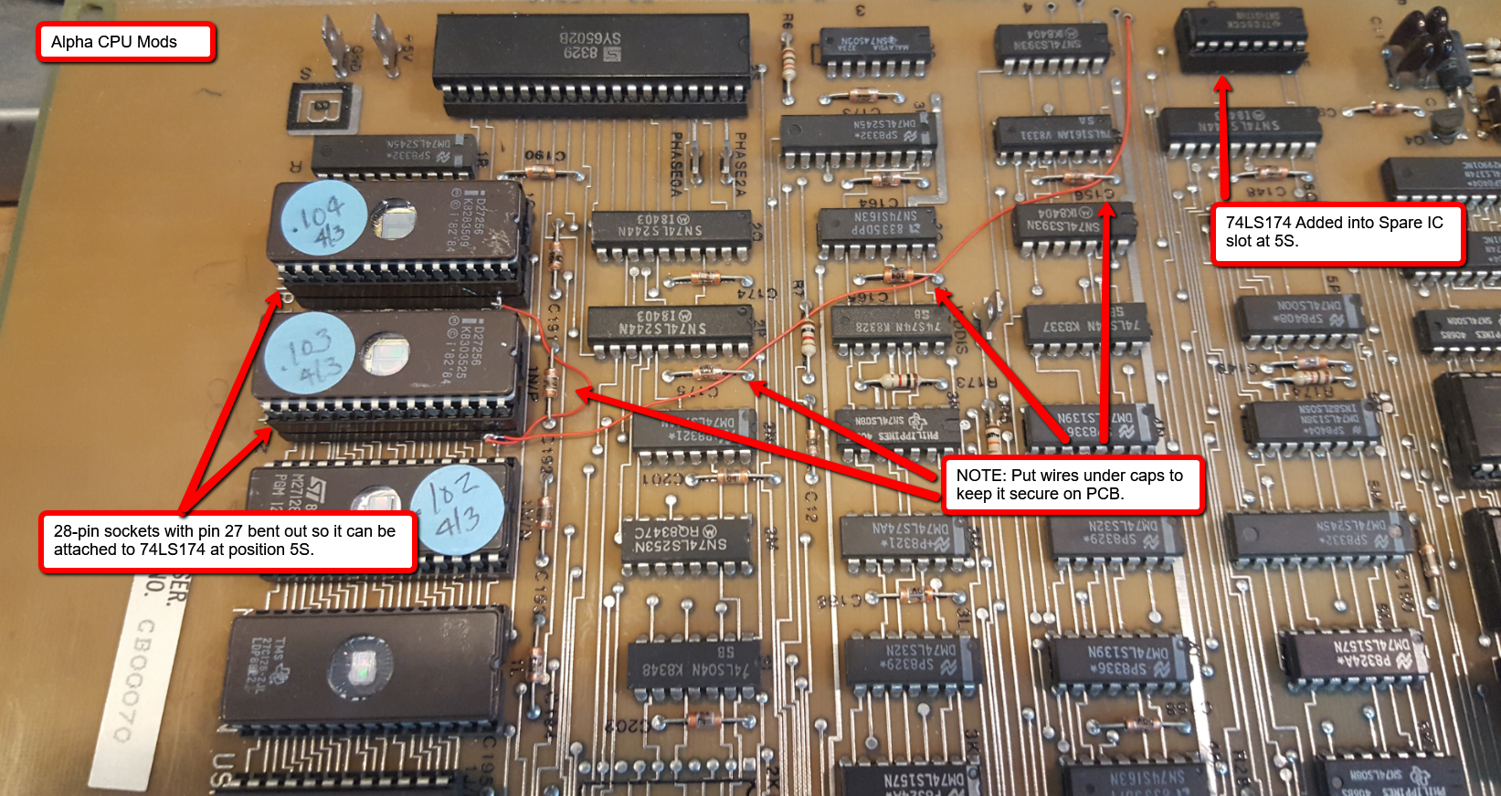

NOTE: 10K resistor not show here yet, photo coming soon.

Full size Images can be found here - <https://github.com/jessaskey/mhavocpe/tree/master/Conversion/Photos>

Speech Circuit – Blatantly borrowed from Mark Spaeth

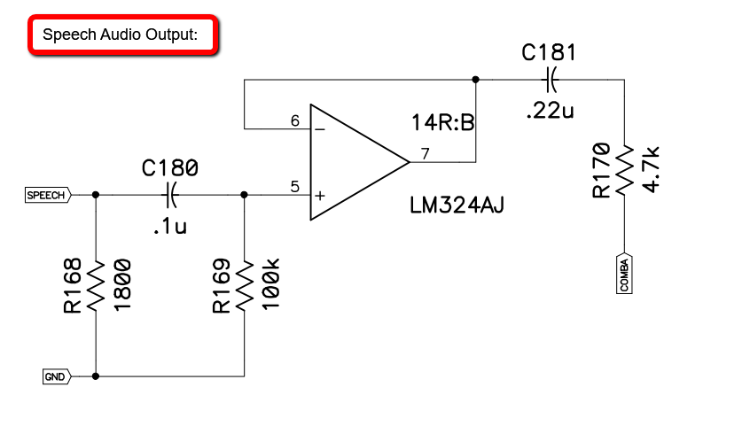

IF YOU HAVE PREVIOUSLY MODDED YOUR PCB:

To revert, you don’t need to uninstall all the devices, just a few. You need to do the following…

1. Remove the additional 28-pin socket and jumper wire for the ROM @ 9S. This is going back to a 27128 now and requires no modification.
2. Remove the 7905 3-Pin Regulator
3. Remove the 14-Pin 74HC04
4. REPAIR the trace that was cut coming off of pin 10 of 11N. It should now run fully out towards the edge of the PCB and up towards the POKEY on the solder side.

Document History:

* Draft 1.11 – 7/25/2022 – Added details on all speech options and mods
* Draft 1.10 – 8/11/2021 – Added resistor to Alpha mod and fixed a couple typos.
* Draft 1.9 – 4/16/2021 – Updated GAMMA mods after switching to ADPCM speech.
* Draft 1.8 – 2/22/2021 – Added more detailed steps for TMS5220 speech circuit modifications.
* Draft 1.7 – 2/12/2020 – Fixed annotation typos on PCB Solder Side, started adding pictures and better documentation for Speech Section.
* Draft 1.6 – 5/12/2018 – Added Speech Schematics from Mark Spaeth.
* Draft 1.5 - 5/2/2018 – Added notes on EPROM sizes required.
* Draft 1.4 - 5/1/2018 – Fixed mis-labeled location 5R with correction location 5S.
* Draft 1.3 - 4/19/2018 – Added text on photos
* Draft 1.2 – 4/15/2018 – Added photos
* Draft 1.1 – 2/12/2018 – Rewrites of descriptions
* Draft 1.0 – 1/15/2018 – Initial draft